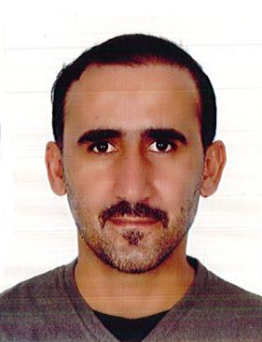**CURRICULUM VITAE**

**SAGHIR MOHAMMAD ALI**

**Mob: 33171719**

**Kingdom Of Bahrain**

**Career Objective**

**To work in any reputed establishment where I can contribute better and enhance myself as well dynamic, hard working, ability to well. That would require challenging employment to utilize and improve my professional skill, alongside, ensure, significant scope for long term carrier developments**

**Personal Details**

**Nationality : Pakistani**

**Date of Birth : 01-01-1982**

**Marital Status : Married**

**Religion : Muslim**

**CPR Number : 820409243**

**Passport No : AQ5941242**

**Languages Known**

* **English, Arabic, Urdu, Hindi**

**License Details**

* **Having Valid Light Vehicle Driving license of Bahrain**

**Education**

* **Primary**

**Professional Qualification**

* **Diploma in Habiliation Tonfa from Special Security Forces directorate, Manama, Bahrain**
* **Attended Public order Training session from Special Security Forces directorate, Manama, Bahrain**

**Work Experience**

* **Worked 2 years as Sales Departments, Bahrain**
* **Worked 13 years in Bahrain Defence force**

**Qualities**

* **Honest, Patient, Kind, Hard working, Trustworthy and Willing to work hard**

**Personal Skills**

* **Have Good Communication,**
* **Interpersonal skills,**
* **Self Confidence Ability to be Responsible.**

**Declaration**

**I hereby declare that the above mentioned information is correct and true to my knowledge.**

**SAGHIR MOHAMMAD ALI**